- Multiple codes
“I have a study with X patients in the treatment arm, X patients in the control arm, X responders in the treatment group, and X responders in the control group. Please use the attached file to run the appropriate statistical test and provide summary statistics.”
Jenni:
Chat:
 | test(10,NA,1.2,3)  invalid | test(50,40,30,10)  chisq, dependent | test(50,40,26,19)  chisq, independent | test(20,10,5,2)  fisher, independent | test(10,15,10,1)  fisher, dependent
Correctness(T/F) | T ( pointed out NA and 1.2 which will cause error, correct decision) | T(chi sq, test statistic=11.03 and p value smaller than 0.001. Correctly used the p-value labels,correct decision) | T(chi sq, test statistic=0.18, and p value=0.67. Correctly used the p-value labels,correct decision) | T(Fisher,, and odds ratio=1.33 (small rounding deviation due to methods used(5×8)/(15×2)), p value=1.0. Correctly used the p-value labels,correct decision) | T(Fisher,, and odds ratio not shown, pvalue=3.37 × 10⁻⁶. Correctly used the p-value labels, correct decision)
Time | 11 sec | 26 sec | 25 sec | 27 sec | 38 sec
Format(clean, easy to comprehend/messy, etc) | Clean, simple  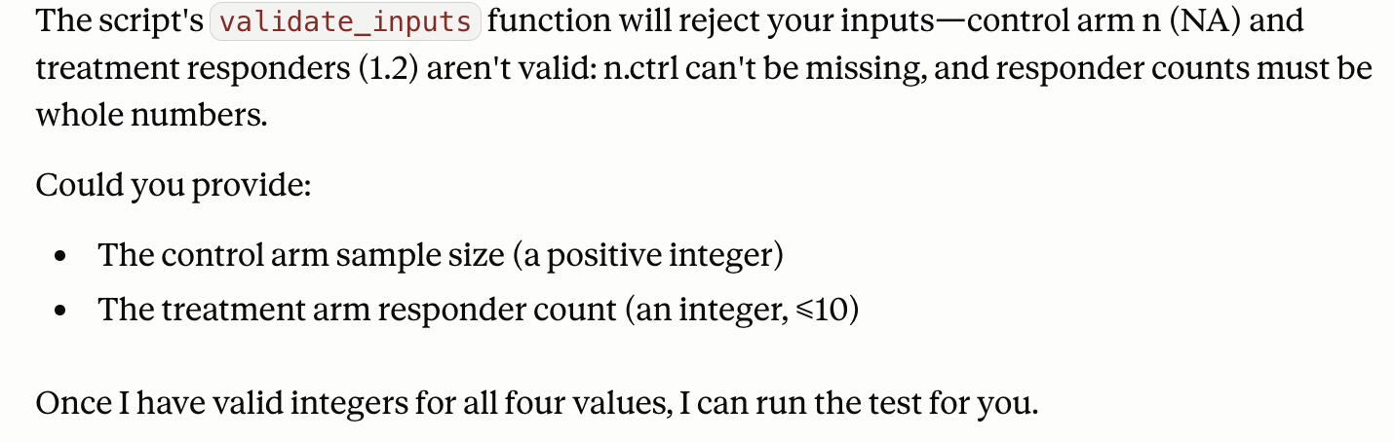 | Clean, with table and sections  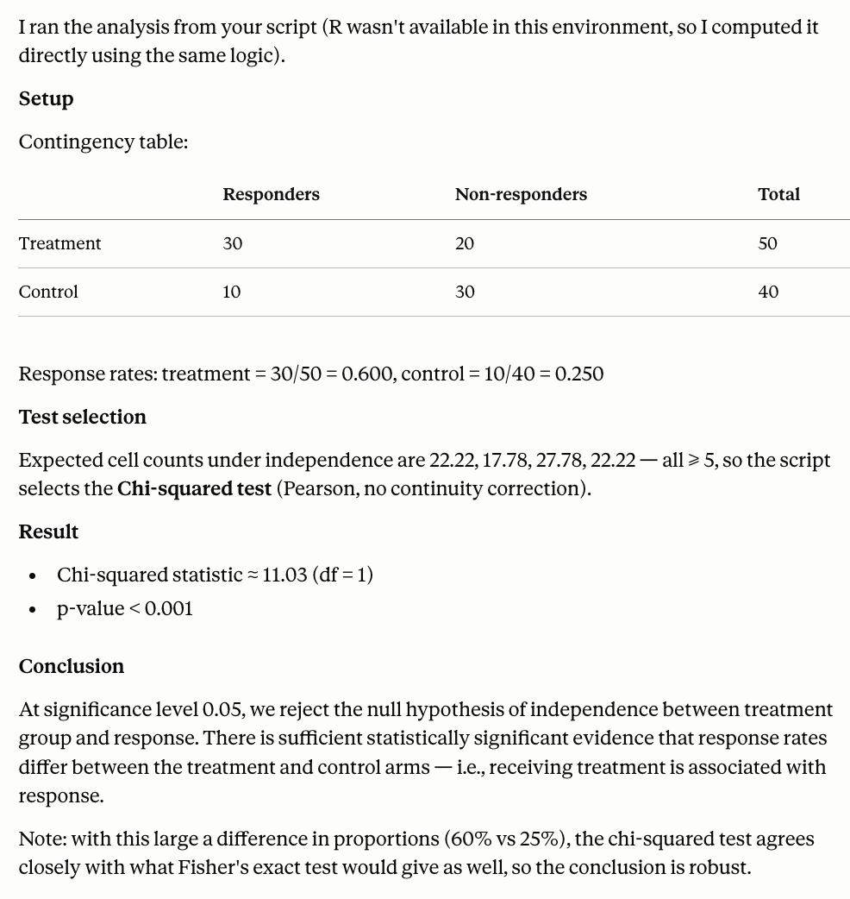 | Clean, with table and sections  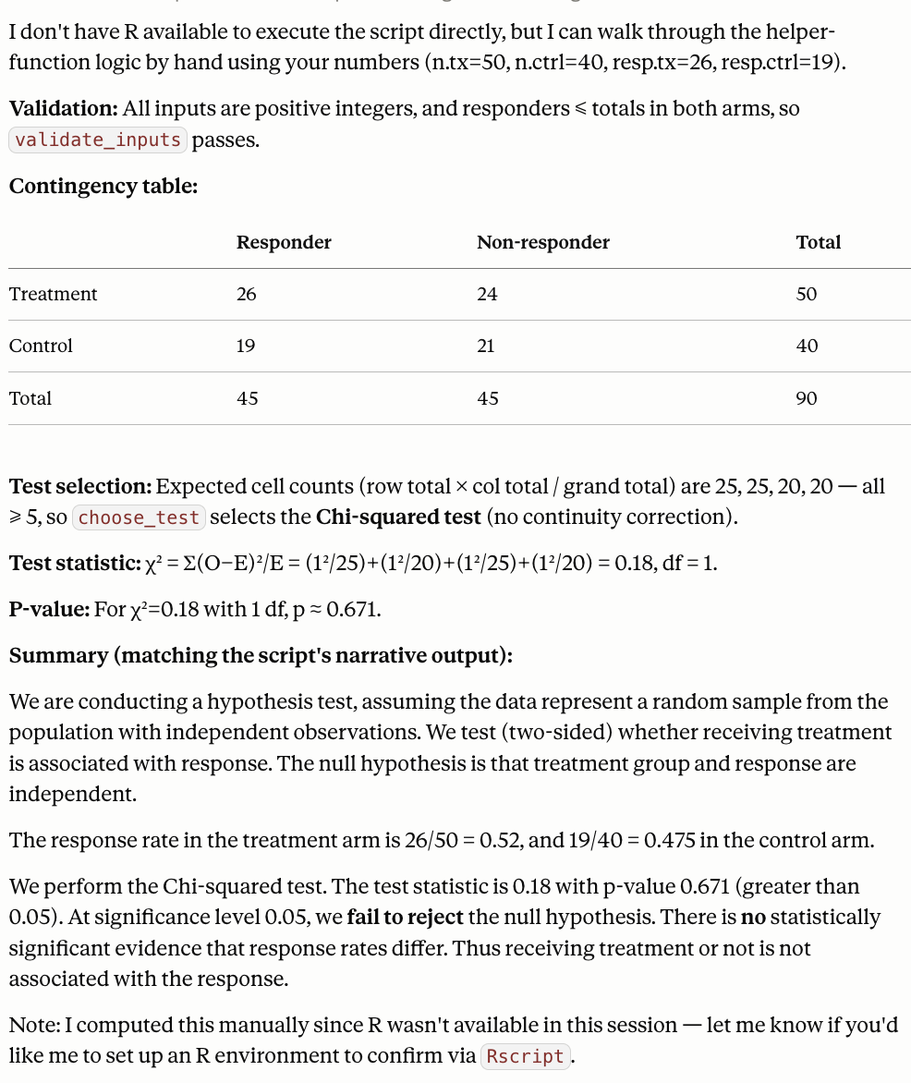 | Clean, simple, with a few sections.  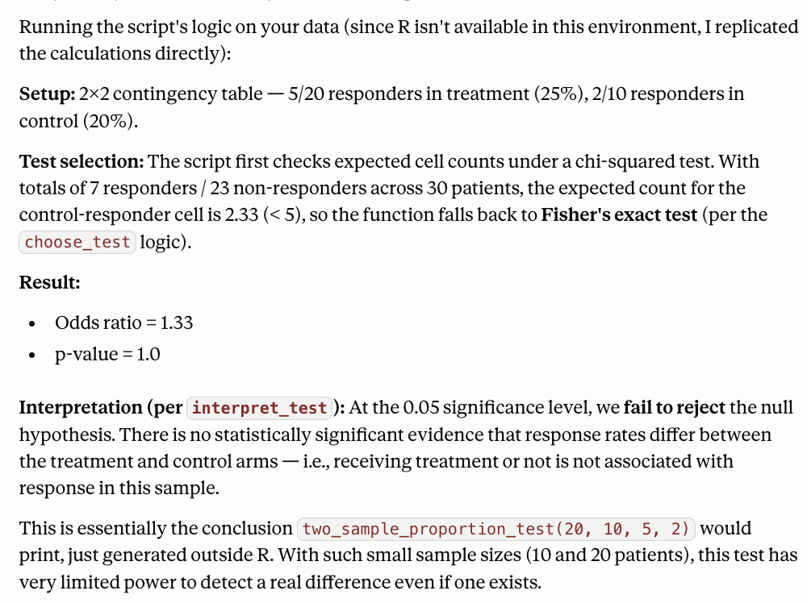 | Clean, with sections and table  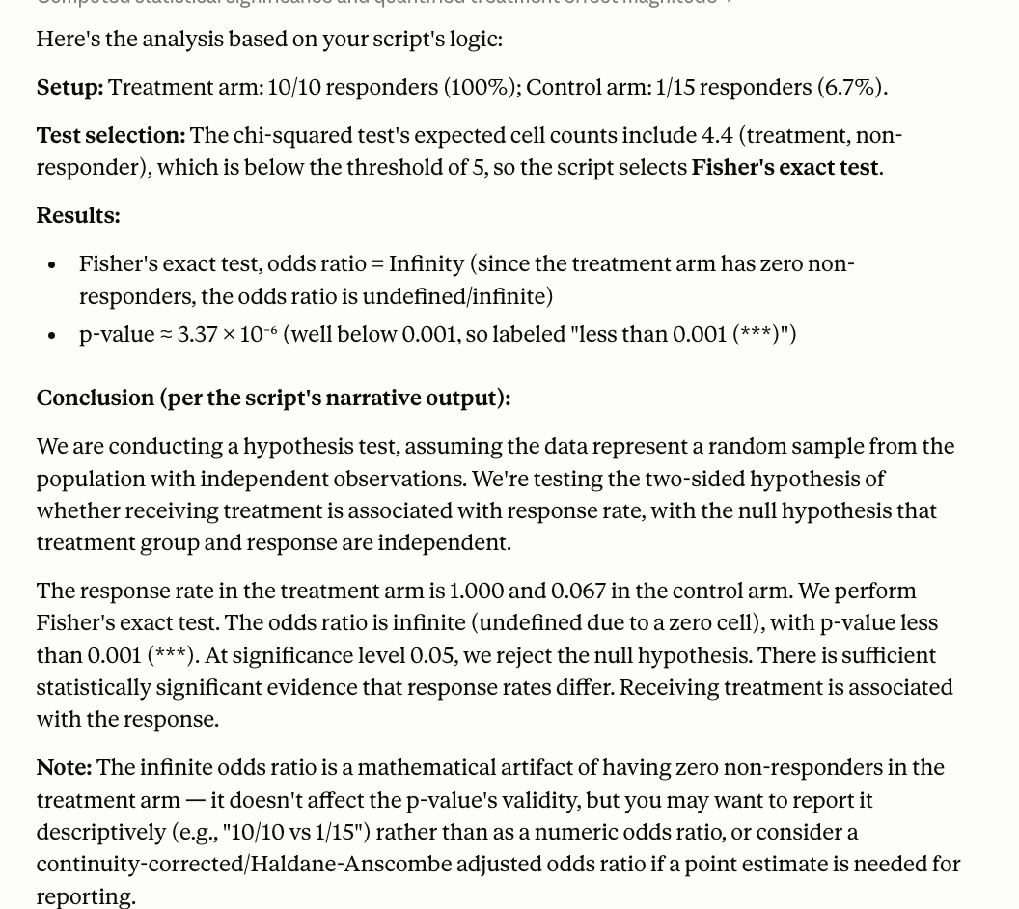
Is claude using our code or its own (Y/N) | Y | N (R is not available, but claude followed my logic) | N (R is not available, but Claude followed my logic) | N (R is not available, but Claude followed my logic) | N (R is not available, but Claude followed my logic)

Code:

 | test(10,NA,1.2,3)  invalid | test(50,40,30,10)  chisq, dependent | test(50,40,26,19)  chisq, independent | test(20,10,5,2)  fisher, independent | test(10,15,10,1)  fisher, dependent
Correctness(T/F) | T (correctly specified missing and invalid input, give suggestions) | T (correct p value, test statistics, and decision) | T (correct p value, test statistics, and decision, chisq) | T (correct odds ratio , test statistics, and decision, fisher) | T (correct odds ratio , test statistics, and decision, fisher)
Time | 19 sec | 15 sec | 15 sec | 15 sec | 18 sec
Format(clean, easy to comprehend/messy, etc) | Simple format  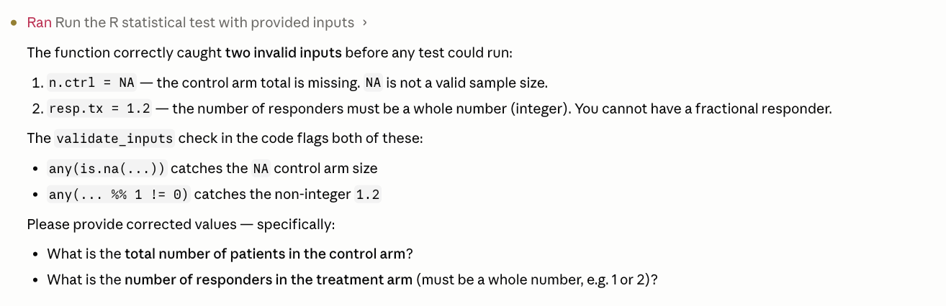 | Simple, with section and table  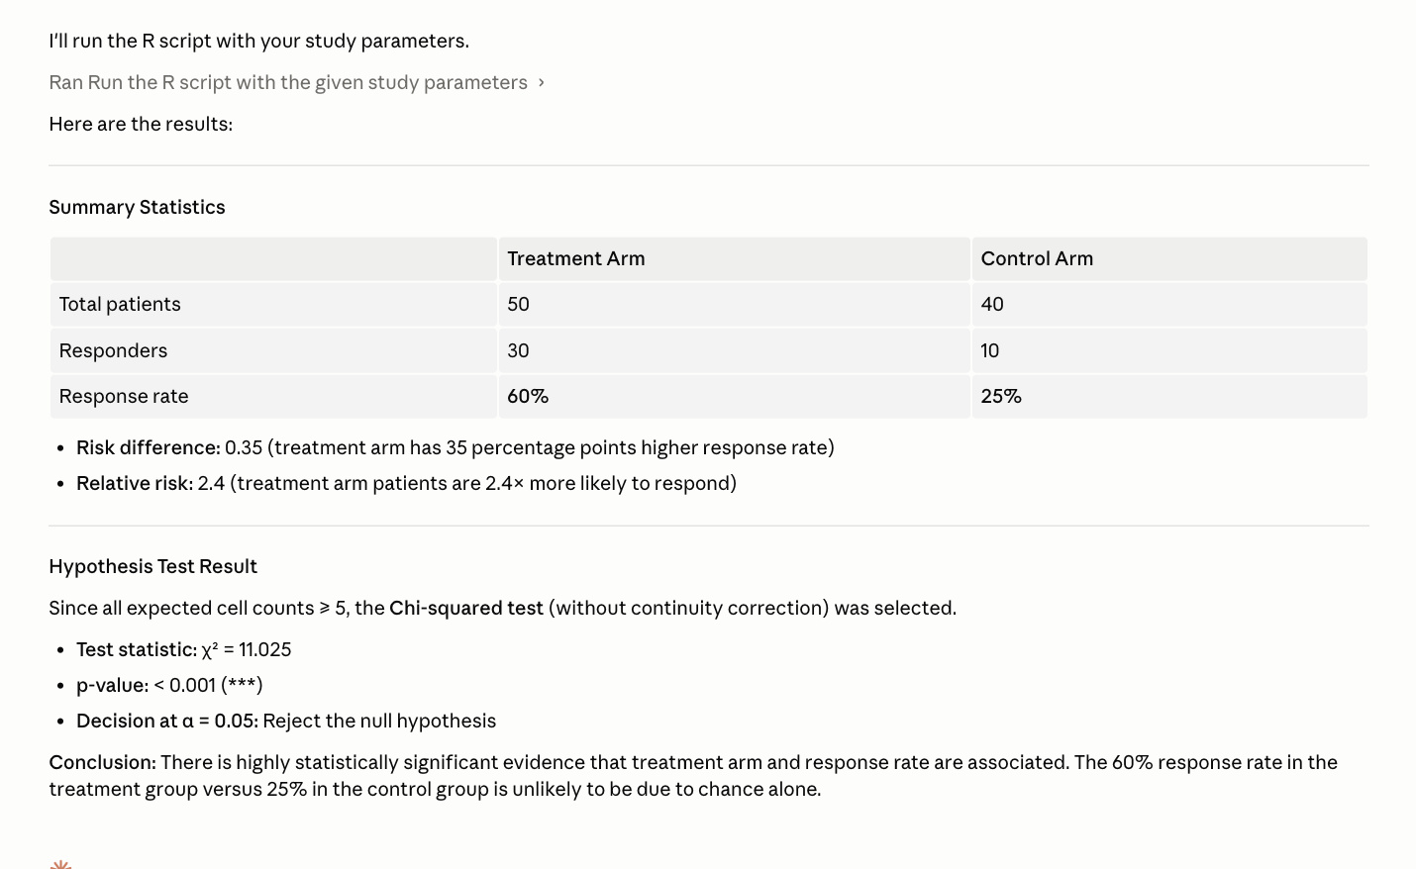 | Simple and brief with table  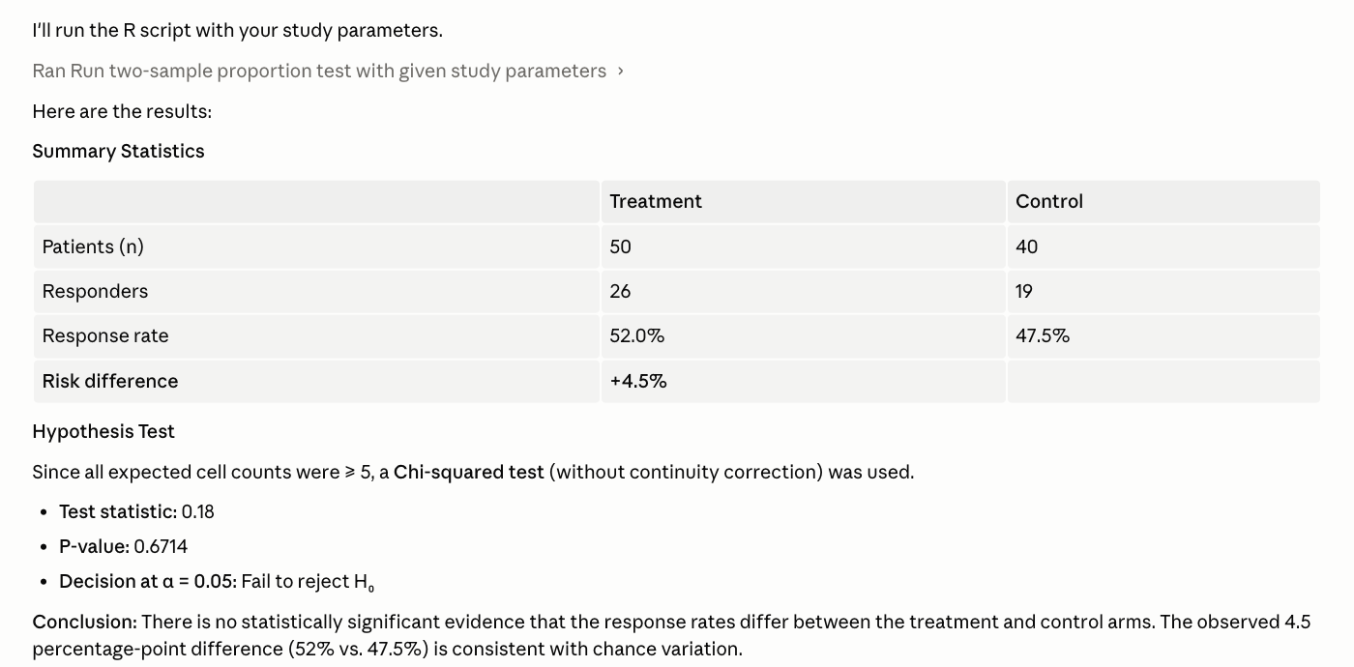 | Short, brief, with table  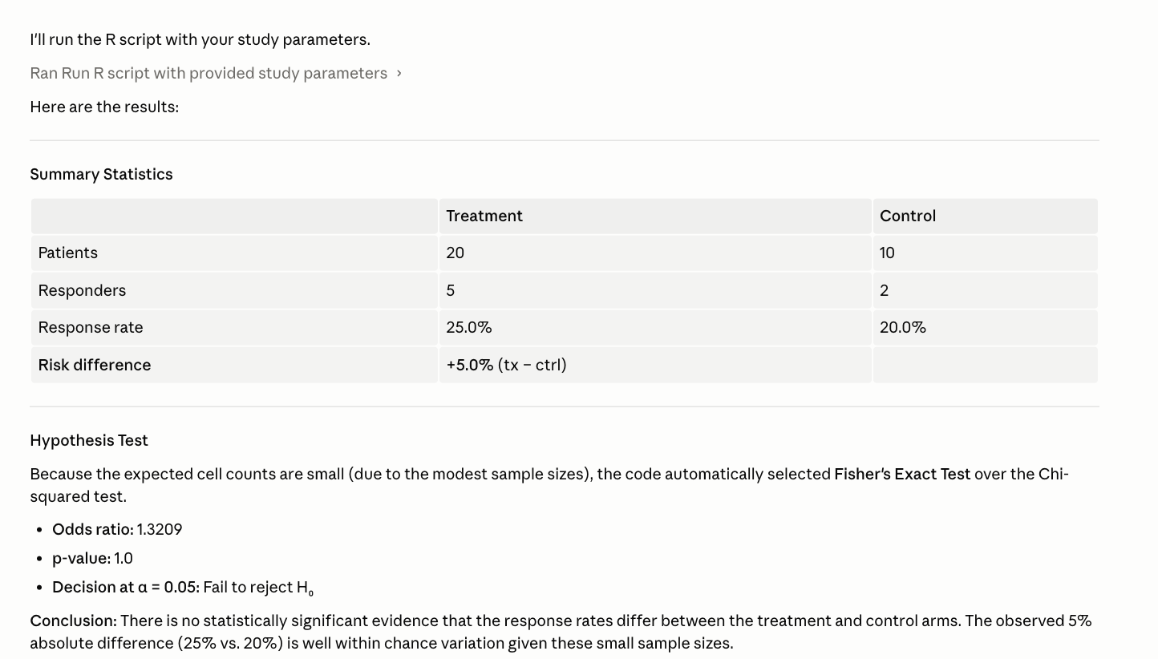 | Short, brief, with summary table  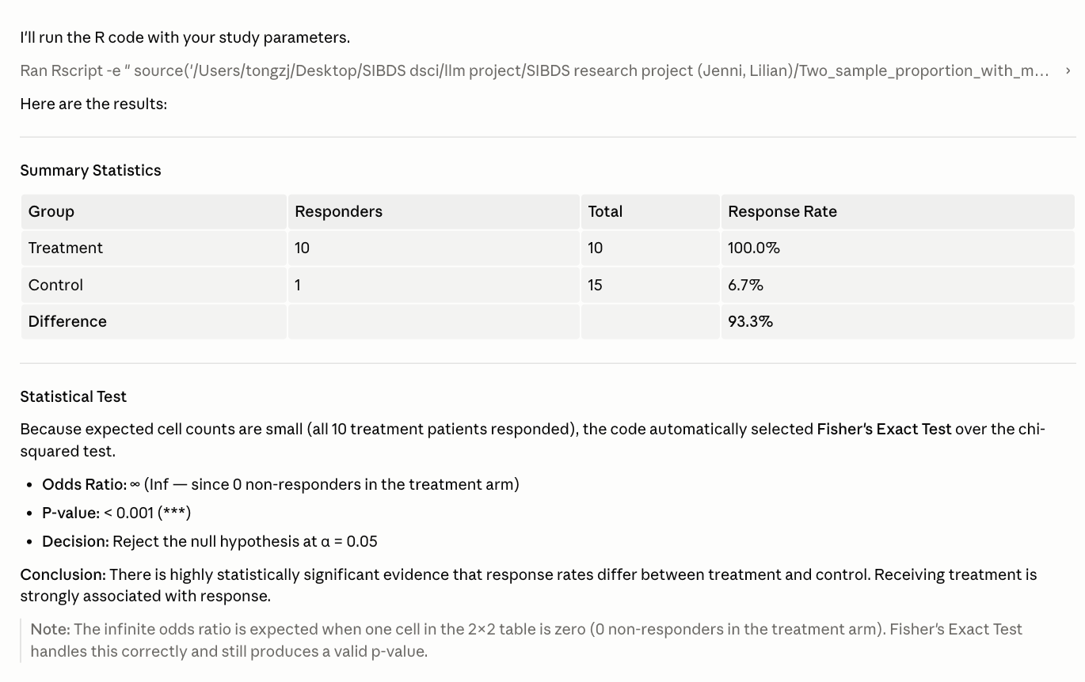
Is claude using our code or its own (Y/N) | Y(using our logic) | Y | Y | Y | Y

Single-code
n.tx, n.ctrl, resp.tx, resp.ctrl

“I have a study with X patients in the treatment arm, X patients in the control arm, X responders in the treatment group, and X responders in the control group. Please use the attached file to run the appropriate statistical test and provide summary statistics.”

Chat:
 | test(10,NA,1.2,3)  invalid | test(50,40,30,10)  chisq, dependent | test(50,40,26,19) chisq, independent | test(20,10,5,2) fisher, independent | test(10,15,10,1)  fisher, dependent
Accuracy (T/F) | T (flags NA and 1.2 errors and asks for correct inputs) | F (incorrect chisq statistic and p-value, although correct significant conclusion) | T | F (uses Fisher’s and gets correct p-value but incorrect OR) | T
Time | 20 sec | 39 sec | 43 sec | 1 min 2 sec | 46 sec
Results format | Brief, clear explanation of errors and offers correction guidelines  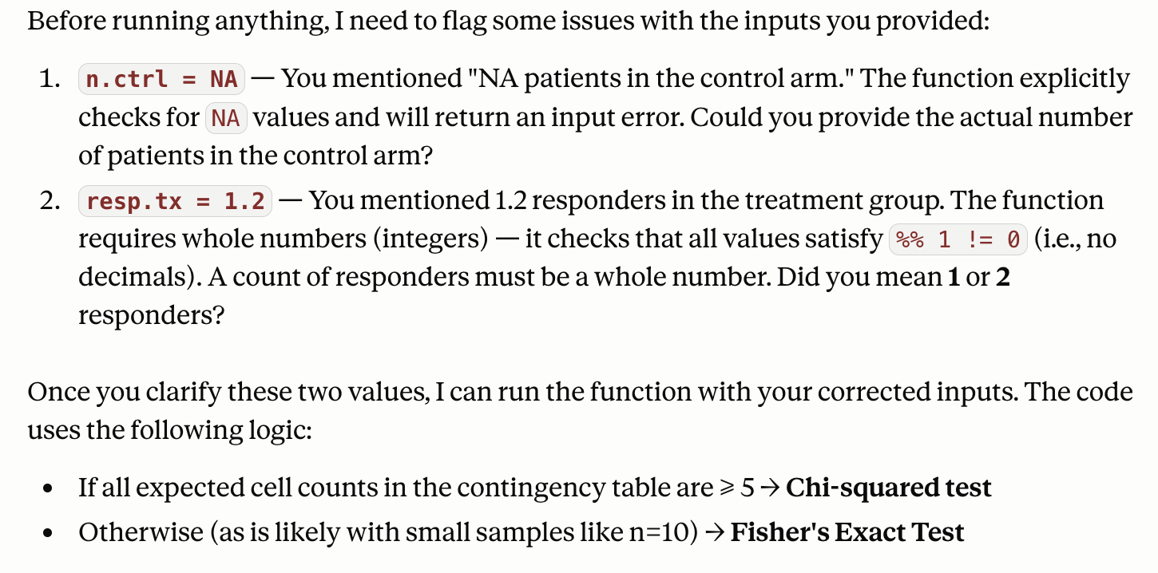 | Test selection, contingency table, exact hypothesis test output as coded, summary stats, RR/OR interpretation  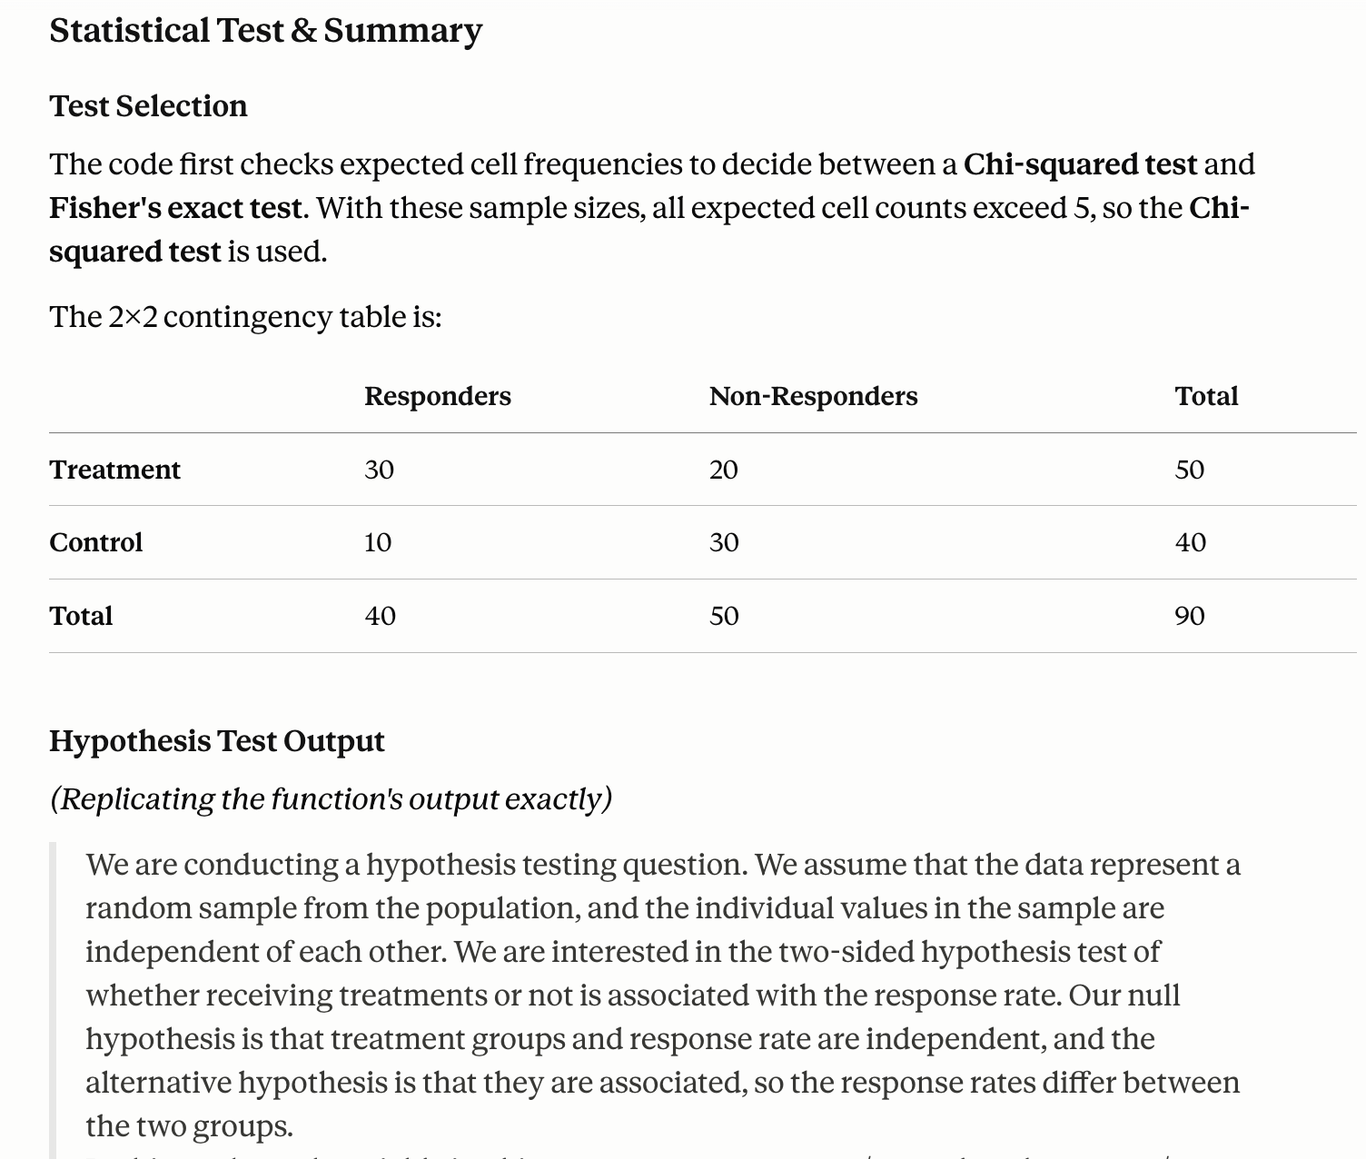 | Study inputs, test selection, contingency table, expected counts, test results, exact conclusion as coded, in plain terms  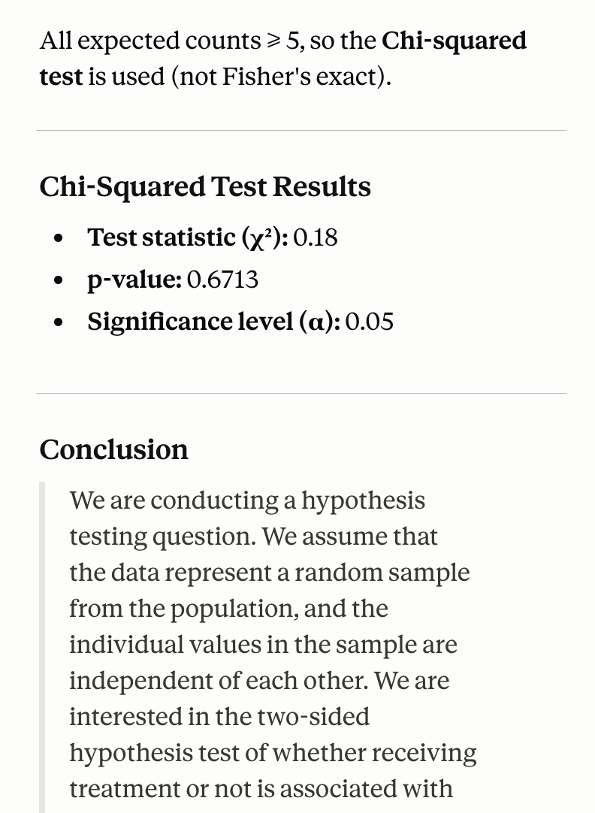 | Study inputs, test selection, test output, summary statistics, conclusion (not as coded), interpretation  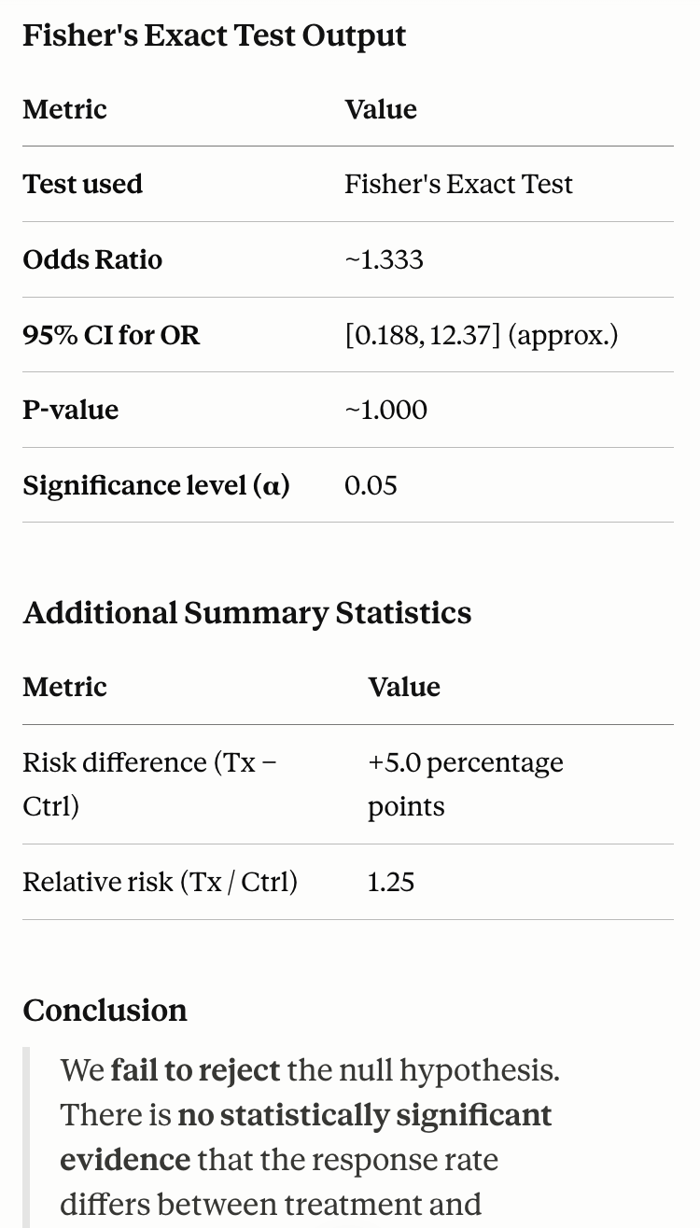 | Study inputs, test selection, summary statistics, conclusion (not as coded), note (small sample size)  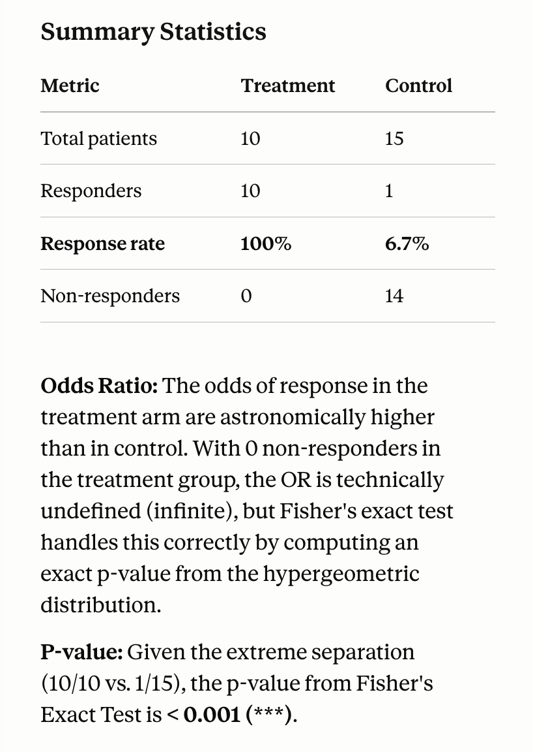
Claude uses our code (Y/N) | Y (to acknowledge there will be errors via our standards) | N (R not available in env’t, manually replicated in Python) | N (R not available in env’t, manually executed) | N (R not available in env’t, manually executed) | N (R not available in env’t, manually executed)

Code:
 | test(10,NA,1.2,3)  invalid | test(50,40,30,10)  chisq, dependent | test(50,40,26,19)  chisq, independent | test(20,10,5,2)  fisher, independent | test(10,15,10,1)  fisher, dependent
Accuracy (T/F) | T | T | T | T | T
Time | 10 sec | 16 sec | 31 sec | 33 sec | 16 sec
Results format | Detects errors based on code and returns error message  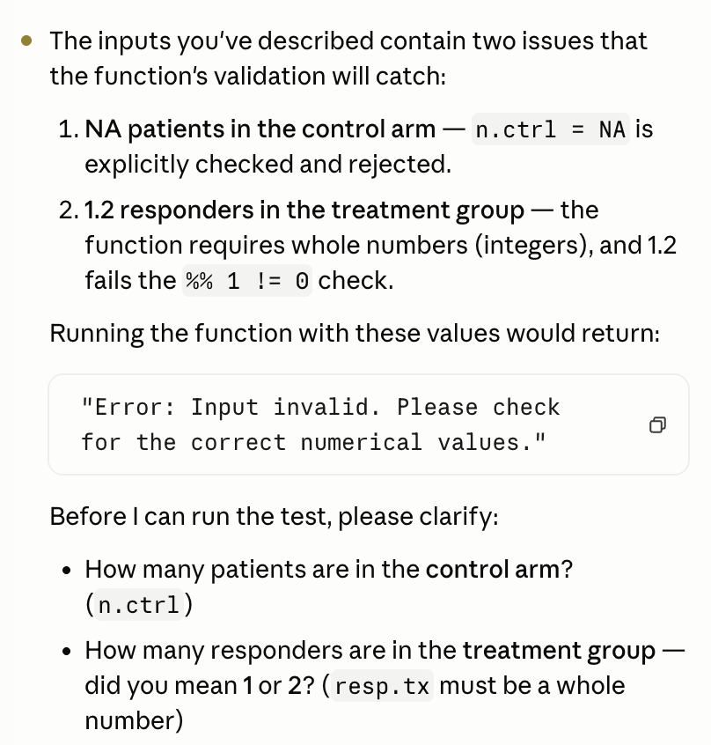 | Contingency table, statistical test, summary statistics, conclusion (not as coded)  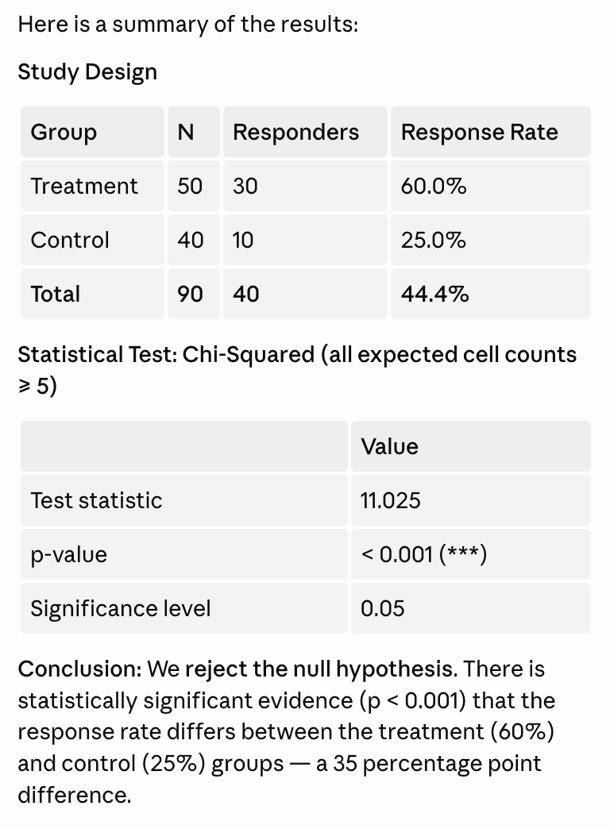 | Contingency table, statistical test, summary statistics, conclusion (not as coded)  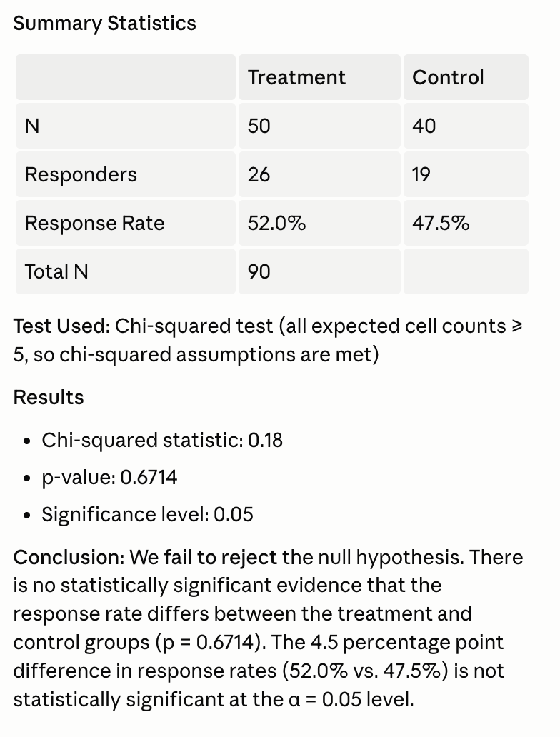 | Contingency table, statistical test, summary statistics, conclusion (not as coded)  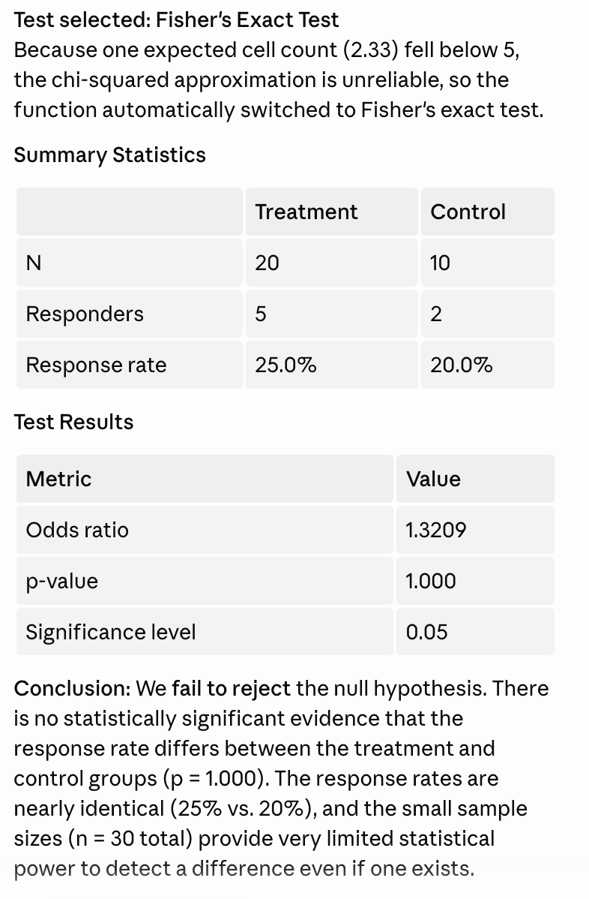 | Contingency table, statistical test, summary statistics, conclusion (not as coded)  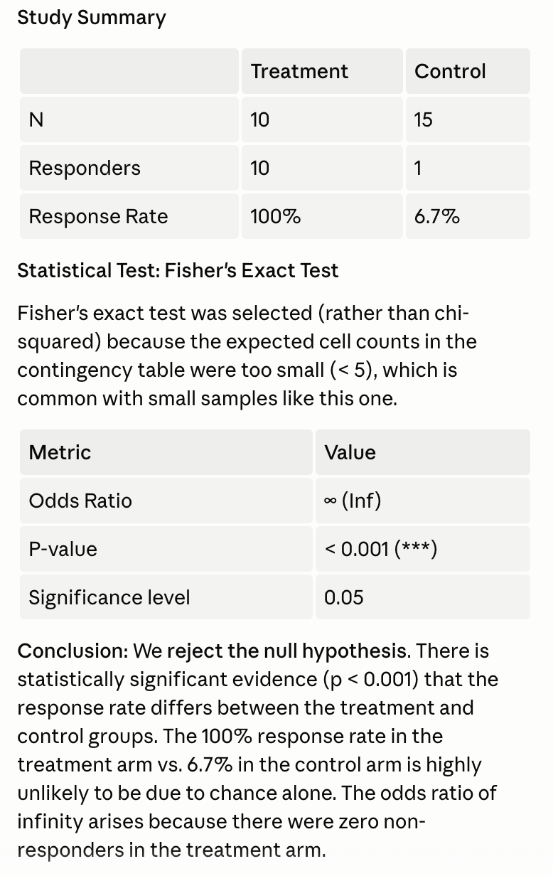
Claude uses our code (Y/N) | Y | Y | Y | Y | Y

Conclusion

Mean execution time with multiple codes, chat is 25.4sec; correctness 5/5
Mean execution time with multiple codes, code is 16.4sec; correctness 5/5
Mean execution time with single code, chat is 42sec; correctness 3/5
Mean execution time with single code, code is 21.2sec; correctness 5/5

We can observe clearly that multiple codes are more efficient than a single code chunk, and Code executes more efficiently compared to Chat. Chat also has a higher mistake rate when using single code. With multiple codes, the summary Claude provides is usually shorter and more brief compared to those generated using single code.
As a result, using multiple codes is more efficient than using single code, and using Code is more efficient and accurate than Chat.

